**Documentation**

*Smart Gas Leakage System*

*Date*

# Team members

Team F

Younsuk Choi

Shihab Ud Doula

Neaz Mahmud

# Introduction

*What are “Internet of Things” and “Wireless Sensors Network” in your project domain about? What is the target application of your project?*

# Concept description

3.1. Block Diagram

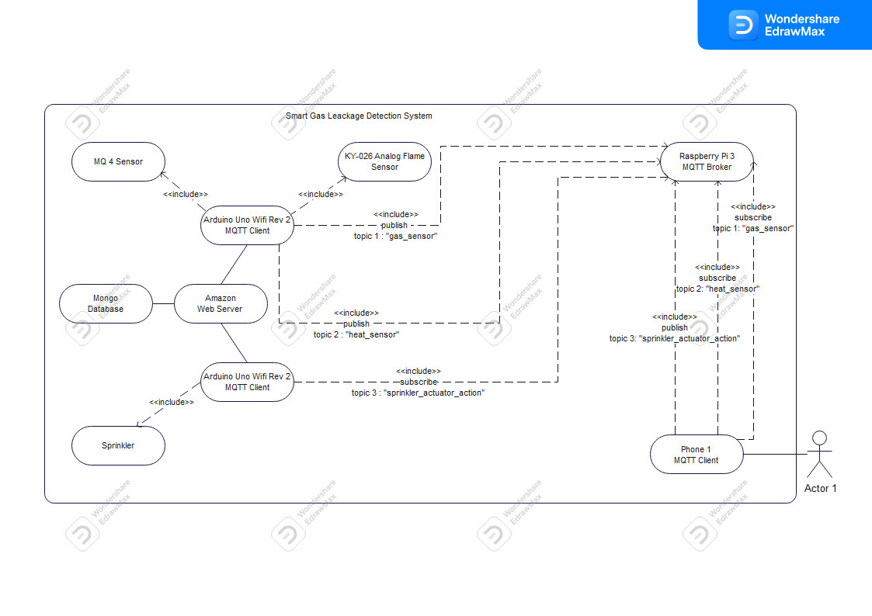

3.2. Project Description

Our Smart Gas Leakage System makes use of a distributed system in which wireless sensor network (WSN) technologies are used to connect microprocessors and sensors/actuators. To be more precise, the environmental restrictions for a room are specified by our smart agribusiness so that we can handle data from gas sensors and flame sensors to monitor the degree of gas leakage and spot potential fires. In our scenario, the Raspberry Pi 3 model will serve as the central communication unit while the Arduino Uno and sensors act as clients, using the server-client approach. This will enable a two-way connection between end users and the actual space. The system can then be controlled either independently or in dependence on the users by instructing the actuators to operate in the proper ways.

3.3. Use of Hardware and Software Components

Hardware

Arduino Uno Wifi Rev 2

Raspberry Pi 3

Sensors and Actuators

- MQ4 Methane Gas Detecting Sensor

- KY026 Analog Flame sensor

- KY019 5V Relay

- KY053 ADC

- DC motor (Simulation of Sprinkler)

Software

Arduino Uno IDE

MQTT Mosquitto

Python Libraries for programming Raspberry Pi for MQTT

# Project/Team management

*Which project methods you used in your project?*

*Breakdown: How you managed your tasks?*

*What are the different tasks/roles of the team members in the project?*

*Describe which team member did which tasks.*

# Technologies

# *Describe the technological approaches you will use to implement your project.*

* *Sensor technologie(s)*
* *Communication protocol(s)*
* *programming language(s)*
* *...*

# Implementation

*Describe the static structure of the environment.*

*Provide a class diagram for this purpose and briefly explain the classes or modules.*

*Describe the use case(s) of your environment*

# Use Case

*Give instructions on how to use your application. Potentially using an/more example(s), figures, screenshots etc.*

# Sources/References

*Provide the sources on the technologies and algorithms you used in your project (Github).*